

**TECHNICAL MANUAL**

IDS/IPS Setup

Linux 2 Web Server

**Prepared By :** Giuseppe Raciti **Prepared on :** 26/06/2023

**Table of Contents**

**Introduction 2**

Purpose and Scope 3

Overview of Snort 3

Key Features 3

Prerequisites 3

Document Structure 3

Document Revision History 3

**System Architecture 3**

Installation 5

Update System Packages 5

Install Snort 5

Configure Snort Network Interface 7

Configure Snort Rules 8

Start Snort 8

Example Alerts 10

User Management 11

Data Ingestion 12

Search and Analysis 13

Data Management 14

Security and Access Control 15

Monitoring and Troubleshooting 16

Maintenance and Upgrades 16

Best Practices 17

Resources and References 17

|  |
| --- |
| Introduction |
| Purpose and Scope The purpose of this document is to provide an overview of Snort, an open-source intrusion detection and prevention system (IDS/IPS), and guide users through its installation and configuration on a Linux system. It aims to assist system administrators and security professionals in setting up Snort to monitor and analyse network traffic for potential security threats. Overview of Snort Snort is a widely used network intrusion detection and prevention system that provides real-time monitoring and analysis of network traffic. It is capable of detecting various types of attacks, including malware, network probes, DoS attacks, and policy violations. Snort can also be configured to actively prevent or block suspicious network activity. Key Features Snort offers several key features that make it a powerful tool for network security:   * **Network Traffic Monitoring:** Snort monitors network traffic in real-time, capturing packets and analysing their contents for potential security threats. * **Signature-based Detection:** Snort uses signature-based detection to identify known attack patterns and malicious activities by comparing packet payloads against a database of predefined rules. * **Protocol Analysis:** Snort can analyse network protocols and detect anomalies or suspicious behaviour that deviates from standard protocol specifications. * **Flexible Rule Engine:** Snort's rule-based engine allows users to create custom rules or modify existing ones to suit specific security requirements. * **Logging and Alerting:** Snort generates logs and alerts whenever it detects suspicious activity, providing detailed information about the detected threats. * **Active Response:** Snort can be configured to actively respond to detected threats by blocking or redirecting network traffic, preventing further damage.  Prerequisites Before proceeding with the installation and configuration of Snort on Linux, ensure that you have the following prerequisites:   * A Linux distribution (e.g., Ubuntu, CentOS) with root access. * Basic knowledge of Linux command-line interface (CLI) and system administration. * Internet connectivity to download necessary packages and updates.  Document Structure This document is structured as follows:  **Introduction:** Provides an overview of the document's purpose, scope, Snort, and its key features.  **Prerequisites:** Lists the requirements for installing and configuring Snort on Linux.  **Installation Steps:** Provides step-by-step instructions for installing Snort on a Linux system.  **Configuration:** Covers the essential configuration steps after installing Snort.  **Verifying Snort Functionality:** Explains how to verify that Snort is functioning correctly.  **Advanced Configuration:** Briefly mentions the availability of advanced configuration options.  **Conclusion:** Wraps up the document and emphasises the successful installation and configuration of Snort. Document Revision History **Date Version Description Author**  2023-06-26 1.0 Initial version Giuseppe Raciti  Note: This document revision history table provides information about the different versions of the document and any significant changes made during each revision. |

|  |
| --- |
| System Architecture |
| Snort's system architecture on Linux encompasses various components and their interactions to provide effective intrusion detection and prevention capabilities. Let's explore the detailed information about Snort's system architecture on Linux:  **Snort Sensor:**  The Snort sensor is the core component responsible for capturing and analysing network traffic.  It operates in one of the following modes: packet sniffer mode, packet logger mode, or network intrusion detection mode.  In packet sniffer mode, the sensor passively captures network packets from a specified network interface.  In packet logger mode, the sensor logs captured packets to disk for later analysis.  In network intrusion detection mode, the sensor analyses captured packets in real-time and detects potential security threats based on predefined rules.  **Snort Rules:**  Snort relies on rules to detect various types of network attacks and anomalies.  Rules define specific conditions or patterns that Snort should look for in network traffic.  Each rule consists of components, including the rule header, rule options, and rule actions.  Rule headers specify the protocol, source and destination IP addresses, ports, and other criteria.  Rule options provide additional conditions or specifications for the rule, such as payload content or detection thresholds.  Rule actions determine the action Snort should take when a rule matches a packet, such as generating an alert or blocking the traffic.  **Preprocessors:**  Snort utilises preprocessors to perform additional analysis on network traffic before applying the rules.  Preprocessors preprocess packets to extract relevant information and perform tasks such as IP defragmentation, reassembly of fragmented packets, decoding protocols, and detecting protocol anomalies.  Preprocessors enhance Snort's detection capabilities and help in analysing complex network traffic.  **Detection Engine:**  The detection engine is responsible for matching network packets against the defined rules to identify potential security threats.  It analyses packet payloads, headers, and metadata to detect known attack patterns or anomalies.  Snort employs various algorithms, such as pattern matching and stateful inspection, to efficiently process and analyse packets.  When a packet matches a rule, the detection engine generates an alert or takes the specified action.  **Output Modules:**  Snort provides output modules that handle the generated alerts and log data.  These modules store alerts and logs in different formats and send them to various destinations.  Common output modules include log file output, database output, syslog output, and unified output (unified2).  **Configuration File:**  Snort's configuration file (/etc/snort/snort.conf) contains the settings and options that define how Snort operates.  Administrators can customise various aspects of Snort's behaviour by modifying the configuration file.  Configuration options include network interface configuration, rule inclusion/exclusion, preprocessors, output modules, and logging settings.  **Integration with Other Tools:**  Snort can be integrated with other security tools and components in the network infrastructure.  It can work in conjunction with network taps, switches, routers, and other security devices to enhance overall network security.  Overall, Snort's system architecture on Linux provides a robust framework for network intrusion detection and prevention. It combines packet capture, rule-based analysis, preprocessors, and output modules to detect and respond to potential security threats effectively. Administrators can configure and customise Snort to meet their specific security requirements. |

|  |
| --- |
| Installation |

## Update System Packages

Start by updating the system packages to their latest versions using the package manager of your Linux distribution. For example, on Ubuntu, run the following command: sudo apt update && sudo apt upgrade

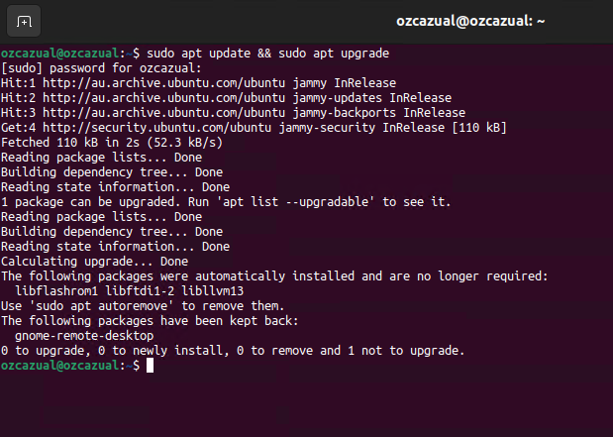

If your system is up to date, you will return a response as shown above

## Install Snort

Install Snort and its dependencies using the package manager.

On Ubuntu, use the following command: sudo apt install snort

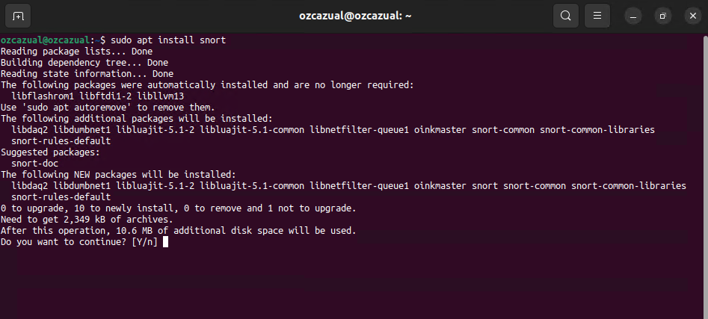

When prompted, enter ’y’ and press ‘ENTER’ to continue

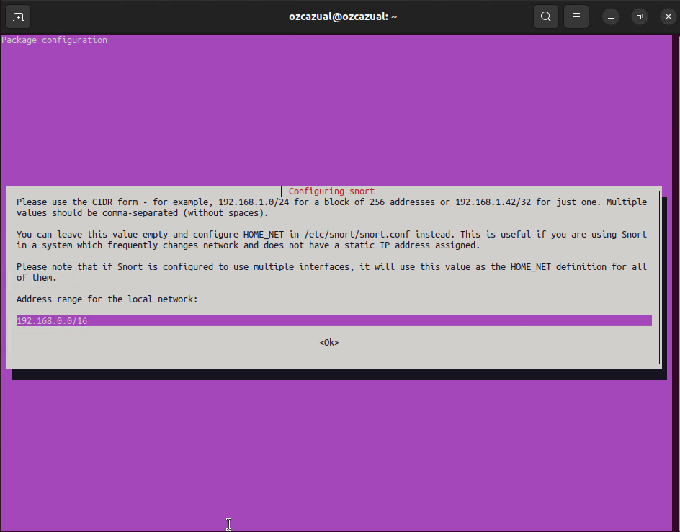

During the installation, a dialog box will appear, requiring the Network address with the Bit value of the subnet.

If you do not input an address, it will default to ‘Any’. Otherwise, input ’**192.168.0.0/24**’ for this instance

As indicated, this can always be changed later, through the **snort.conf** file

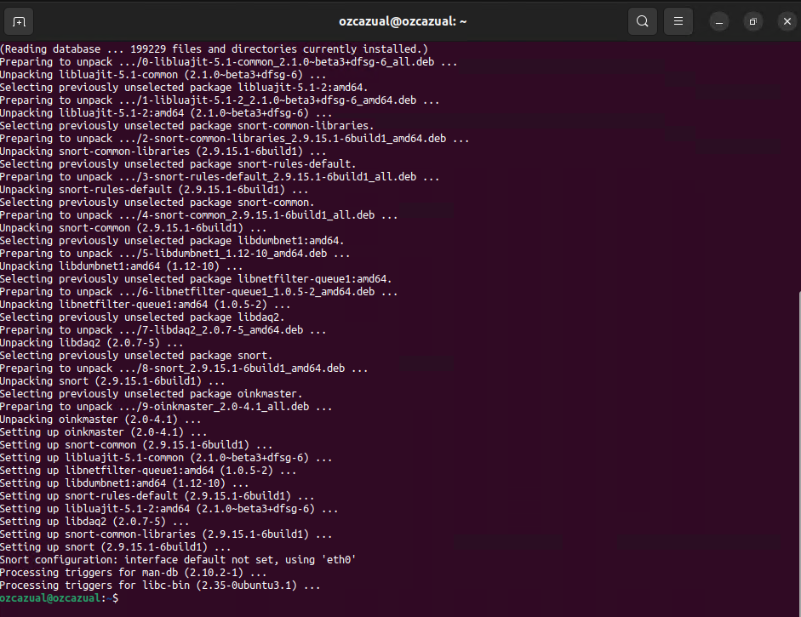

The installation will continue, until it displays as above, and the installation is complete.

## Configure Snort Network Interface

To capture network traffic, Snort needs to be configured with the appropriate network interface.

Identify the network interface you want to monitor by running the following command: ‘ ifconfig -a ‘

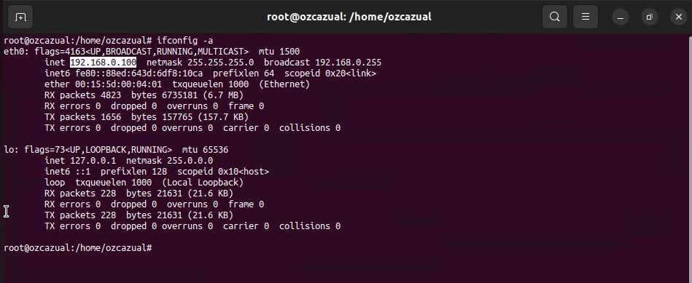

Note the IP address of the network card. In this case, **eth0** has the address ‘ **192.168.0.100** ‘

Now, we need to edit the Snort configuration file **/etc/snort/snort.debian.conf**

Run the following command: sudo nano /etc/snort/snort.debian.conf

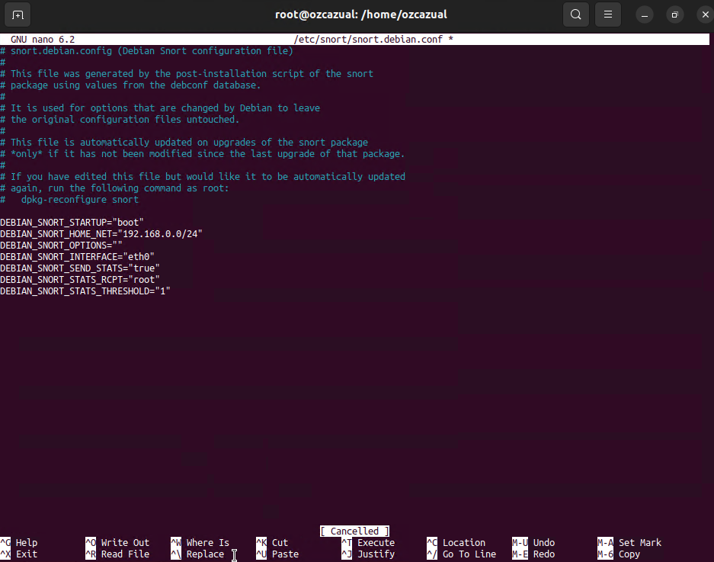

Here, we can set the adaptor that Snort is monitoring, and the address of the network if changes are needed.

**Save and exit the file:** After making the necessary changes, save the file and exit the text editor. In nano, you can do this by pressing **Ctrl + X**, then confirming the save by pressing **Y** and hitting **Enter**.

## Configure Snort Rules

Snort relies on rules to detect and respond to network intrusions.

By default, Snort comes with a set of community rules.

To enable these rules, open the configuration file: sudo nano /etc/snort/snort.conf

Find the line that starts with **# include $RULE_PATH/local.rules** and uncomment it. Save and close the file.

## Start Snort

To start Snort, use the following command:

sudo snort -A console -c /etc/snort/snort.conf -i eth0

The options included in the start command include:

**-A <alert mode>** : Specifies the alert mode, such as "fast" for minimal alerts or "full" for detailed alerts.

**-c <config file>** : Specifies the path to the Snort configuration file

**-i <interface>** : Specifies the network interface to listen on for network traffic

Snort will being initialising as shown below.

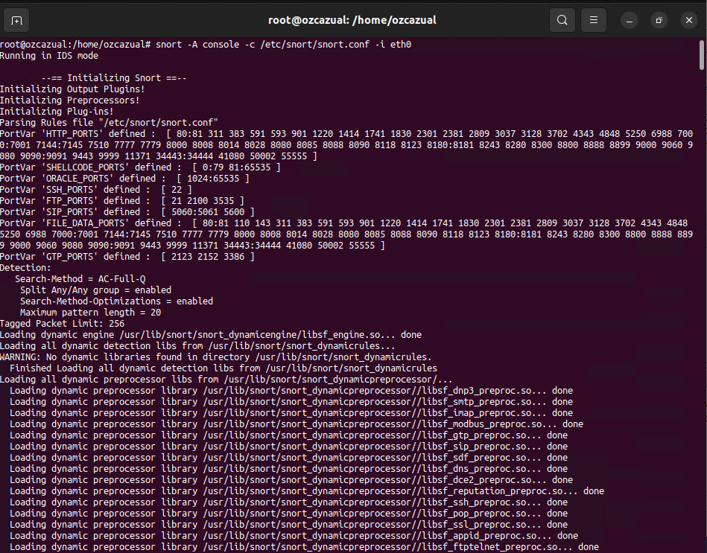

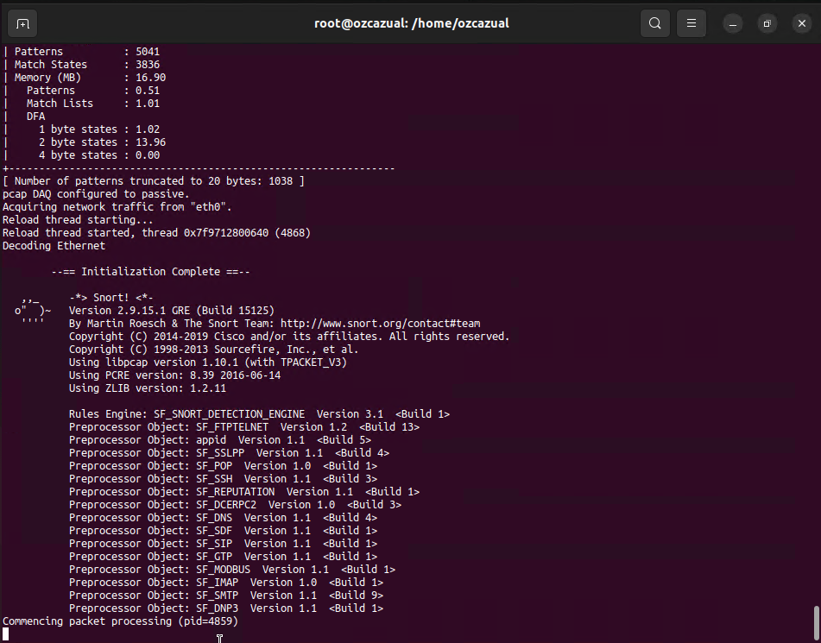

Snort is now running, and monitoring traffic.

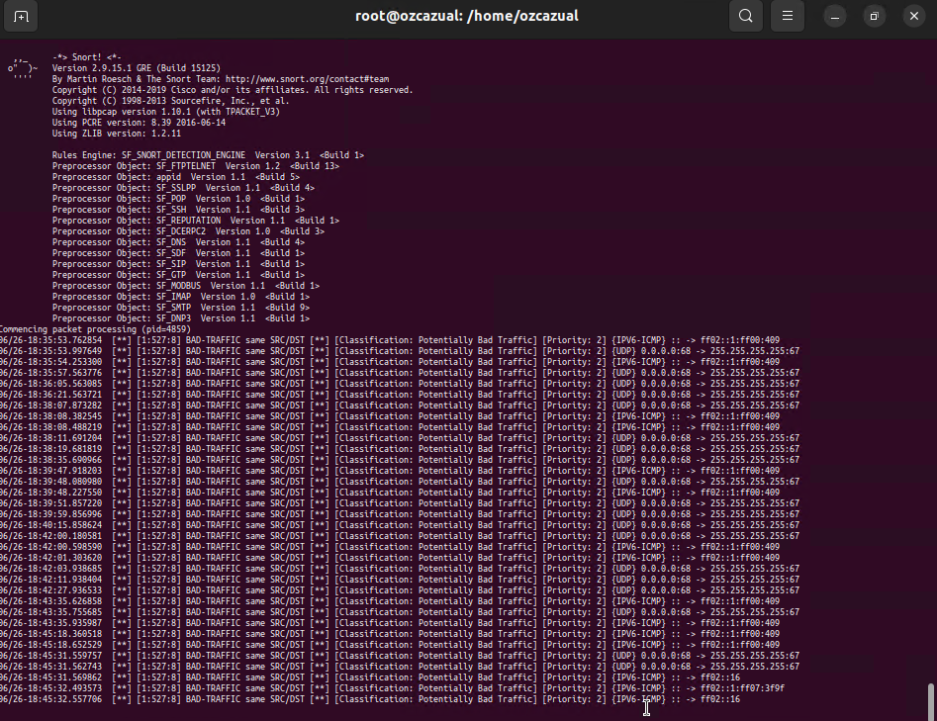

The information now produced by Snort details information about the traffic that has raised any kinds of alerts, dependant on the rules that have been configured. Depending on what rules have been configured, Snort can detect additional traffic activity that requires attention.

## Example Alerts

If an SSH brute-force attack was performed using the Nmap script ssh-brute, it triggers an alert in Snort, the specific alert message will depend on the Snort rules and configurations you have in place.   
However, in the context of an SSH brute-force attack, a typical alert generated by Snort may indicate a suspicious or malicious activity related to SSH authentication. Here's an example of what the alert message might look like:

[**] [1:1234567:4] SSH Brute-Force Attack Detected [**] [Classification: Attempted Administrator Privilege Gain] [Priority: 1] 06/26-2023 10:30:45.123456 192.168.0.103:12345 -> 192.168.0.100:22 TCP TTL:64 TOS:0x0 ID:12345 IpLen:20 DgmLen:60 DF ***AP*** Seq: 0x12345678 Ack: 0x87654321 Win: 0x1234 TcpLen: 32

In the above example:

**[**] [1:1234567:4]** indicates the rule ID and its associated metadata.

**SSH Brute-Force Attack Detected** provides a descriptive message about the detected activity.

**[Classification: Attempted Administrator Privilege Gain] [Priority: 1]** gives additional information about the severity or classification of the alert.

**06/26-2023 10:30:45.123456** indicates the date and timestamp of the alert.

**192.168.0.103:12345** represents the source IP address and port of the attacker.

**192.168.0.100:22** represents the destination IP address and port of the SSH server.

The following lines provide additional information about the network packets involved in the attack.

The actual alert message may vary depending on your Snort configuration, rule sets, and the specific rules enabled for SSH-related activity monitoring.

|  |
| --- |
| User Management |

Snort itself does not have a built-in user management system. However, when deploying Snort on Linux, you can leverage the user management capabilities provided by the operating system to control access to Snort and its related components.

Below is detailed information about managing Snort users on Linux:

**Operating System User Management:**

* Linux provides user management functionalities through tools such as **useradd**, **usermod**, and **userdel**.
* To manage users on Linux, you can use these tools to create and manage user accounts with appropriate privileges.
* Create a dedicated user account for Snort to enhance security and restrict access to sensitive resources.
* Use the **useradd** command to create a new user account: **sudo useradd -m -s /bin/bash snort_user**.
* Set a strong password for the Snort user using the **passwd** command: **sudo passwd snort_user**.
* Modify user account settings using the **usermod** command: **sudo usermod -aG snort_group snort_user**.
* Use the **userdel** command to delete a user account: **sudo userdel snort_user.**

**File System Permissions:**

* Adjust file system permissions to control access to Snort-related files and directories.
* Assign ownership and appropriate permissions to directories, configuration files, and log files used by Snort.
* Ensure that only authorised users or groups have read, write, or execute permissions as necessary.

**Access Control Lists (ACLs):**

* Linux supports Access Control Lists (ACLs), which provide more fine-grained control over file and directory permissions.
* Use ACLs to grant or restrict access to specific files or directories for Snort users.
* The **setfacl** command can be used to manage ACLs on Linux systems.

**Sudo Privileges:**

* Grant sudo privileges to specific users or groups to allow them to execute Snort-related administrative tasks.
* Modify the sudoers file using the **visudo** command to specify which commands and options the Snort user can execute with elevated privileges.

**Multi-User Environment:**

* In a multi-user environment, where multiple administrators may need to manage Snort, consider creating a separate group and assigning appropriate permissions to the group's members.
* This ensures collaboration and facilitates shared management of Snort and its related resources.

By leveraging the user management capabilities provided by the Linux operating system, you can control access to Snort and ensure that only authorised individuals can interact with the system, configure settings, and perform administrative tasks.

|  |
| --- |
| Data Ingestion |

Snort, as an intrusion detection and prevention system, ingests and processes network traffic data on Linux for analysis and detection of potential security threats. Here is a detailed explanation of Snort's data ingestion on Linux:

Snort requires network interfaces to capture and ingest network traffic data. You need to configure the network interfaces on your Linux system to enable Snort to capture the desired network traffic. Tools like **ifconfig** or **ip** can be used to configure network interfaces, assign IP addresses, and set promiscuous mode if necessary.

Snort uses libpcap, a packet capture library, to capture network packets from the configured network interface(s). It can capture packets in real-time or from packet capture files. Snort's configuration file (/etc/snort/snort.conf) specifies the network interface(s) to capture packets from.

Once Snort captures packets, it decodes and analyses the packet contents to identify potential security threats. Snort examines various aspects of the packet, including packet headers, payloads, and metadata. It uses preprocessors and detection engines to analyse packet data and compare it against predefined rules to identify suspicious activity.

Snort employs rules to detect specific types of network attacks and anomalies. Rules define the conditions or patterns that Snort should look for in the network traffic data. Snort's rule management component handles the storage, organisation, and updating of rules used for analysis. When a packet matches a rule, Snort generates alerts or takes specified actions to notify administrators of potential security threats.

Snort logs information about captured packets, alerts, and other relevant data for further analysis. Administrators can configure the logging options in Snort's configuration file to define the log format, location, and verbosity levels. Snort can generate various types of logs, including packet logs, alert logs, and unified logs, which provide consolidated information about captured packets and detected threats.

To streamline data ingestion and analysis, Snort can integrate with Security Information and Event Management (SIEM) systems or log management solutions. SIEM systems collect, correlate, and analyse logs and security events from various sources, including Snort. Snort can be configured to forward logs or alerts to SIEM systems via protocols like Syslog or using specific SIEM integration plugins. Log management systems facilitate centralised storage, search, and analysis of Snort's logs for efficient incident response and threat hunting.

By capturing and processing network traffic data, Snort on Linux performs data ingestion and analysis to identify potential security threats. Its rule-based analysis, logging capabilities, and integration options enable effective monitoring and detection of suspicious activity in network environments.

|  |
| --- |
| Search and Analysis |

Snort on Linux provides search and analysis capabilities to identify potential security threats in network traffic data.

**Packet Decoding and Analysis:**

* Snort decodes and analyses captured network packets to extract meaningful information for threat detection.
* It examines packet headers, payloads, and metadata to identify suspicious activity or patterns.
* Snort's analysis includes protocol decoding, reassembling fragmented packets, and inspecting packet content for potential threats.

**Rule-Based Analysis:**

* Snort employs a rule-based approach to detect various types of network attacks and anomalies.
* Rules define specific conditions or patterns that Snort should search for in the network traffic data.
* Snort compares captured packets against the defined rules to identify potential security threats.
* When a packet matches a rule, Snort generates alerts or triggers specified actions to notify administrators of potential threats.

**Preprocessors and Detection Engine:**

* Snort uses preprocessors and a detection engine to enhance its search and analysis capabilities.
* Preprocessors preprocess packets to extract relevant information and perform tasks such as IP defragmentation, reassembly of fragmented packets, and protocol anomaly detection.
* The detection engine applies rule-based analysis and uses various algorithms, including pattern matching and stateful inspection, to efficiently process and analyse packets for potential threats.

**Logging and Alerting:**

* Snort logs relevant information about captured packets, alerts, and other data for further analysis.
* Administrators can configure logging options to specify the log format, location, and verbosity levels.
* Snort can generate different types of logs, such as packet logs, alert logs, and unified logs, providing consolidated information about captured packets and detected threats.
* Alerts are generated when a packet matches a defined rule, allowing administrators to respond promptly to potential security incidents.

**Integration with SIEM and Log Management Systems:**

* Snort can integrate with Security Information and Event Management (SIEM) systems or log management solutions.
* Integration allows Snort's logs and alerts to be forwarded to a central SIEM or log management system.
* This enables efficient correlation, analysis, and visualisation of Snort data alongside data from other security tools, facilitating comprehensive threat detection and incident response.

**Customization and Rule Management:**

* Administrators can customise Snort's search and analysis capabilities by modifying rules and configuration settings.
* Rule management involves organising, updating, and customising rulesets to adapt Snort to specific security requirements.
* Snort supports the use of community rulesets and allows administrators to create their own rules for targeted threat detection.

Snort's search and analysis functionality on Linux enables the detection of potential security threats by examining network packets, applying rule-based analysis, and generating alerts. Through integration with SIEM and log management systems, administrators can gain comprehensive visibility and streamline incident response. Customization options and rule management provide flexibility to tailor Snort's search and analysis capabilities to specific security needs.

|  |
| --- |
| Data Management |

Snort on Linux requires effective data management practices to handle the storage, indexing, retention, and analysis of network traffic data.

**Indexing Configuration and Best Practices:**

* Snort utilises indexing configurations to organise and optimise the storage and retrieval of indexed data.
* The indexing configuration determines parameters such as index size, number of shards, and replica settings.
* Elasticsearch, commonly used as the indexing engine for Snort, provides various settings and best practices for efficient indexing.
* Follow the recommendations from the Snort and Elasticsearch documentation to optimise indexing performance and scalability.

**Managing Indexes:**

* Indexes in Snort store the captured network traffic data, enabling efficient search and retrieval.
* Snort offers administrative interfaces or command-line tools to manage indexes.
* Create new indexes as needed, delete unnecessary indexes to free up storage space, and modify index settings based on performance and storage requirements.
* Consider factors like index size, storage capacity, and search performance when determining the number and size of indexes.

**Retention Policies:**

* Retention policies determine how long Snort retains indexed data before it is deleted or archived.
* Set retention policies based on compliance requirements, operational needs, and available storage resources.
* Configure retention policies within Snort or integrate with external data management systems to automate the deletion or archiving of older data.
* Regularly review and adjust retention policies to balance storage capacity with the need for historical data analysis.

**Data Lifecycle Management:**

* Data lifecycle management encompasses managing data from its initial capture to eventual disposal.
* Snort provides features and integrations for data lifecycle management, including archiving, freezing, and summarization.
* Archiving involves moving older, less frequently accessed data to long-term storage for historical analysis or compliance purposes.
* Freezing marks data as read-only to preserve its integrity for auditing or forensic investigations.
* Summarization techniques can be applied to aggregate and condense large volumes of data for faster analysis and reduced storage requirements.

**Working with Summary Indexes and Accelerated Data Models:**

* Summary indexes and accelerated data models improve data analysis efficiency in Snort.
* Summary indexes store precomputed aggregated data that can be quickly queried for common analysis tasks.
* Accelerated data models provide optimised data structures and algorithms for specific types of analysis, enhancing query performance.

Leverage these features to expedite searches, generate reports, and gain insights from large volumes of network traffic data.

Effective data management practices in Snort on Linux ensure efficient storage, retrieval, and analysis of network traffic data. By properly configuring indexing, defining retention policies, implementing data lifecycle management, and utilising features like summary indexes and accelerated data models, you can optimise storage utilisation, query performance, and obtain valuable insights from network traffic data.

|  |
| --- |
| Security and Access Control |

Snort on Linux provides various security and access control mechanisms to protect the system and ensure secure operation.

**User Accounts and Privileges:**

* Snort should be run with limited privileges to minimise the potential impact of security breaches.
* Create a dedicated user account for running Snort with the least necessary privileges.
* Restrict access to sensitive Snort files and directories by setting appropriate ownership and permission settings.
* Regularly review and update user account privileges to adhere to the principle of least privilege.

**Configuration Hardening:**

* Harden the Snort configuration files by following security best practices.
* Remove any unnecessary modules or features that are not required for the specific deployment.
* Disable or restrict any unused network interfaces or protocols in Snort's configuration.
* Configure logging and alerting mechanisms securely to protect sensitive data from unauthorised access.

**Network Security:**

* Implement network-level security controls to protect the Snort system.
* Utilise firewalls or network access control lists (ACLs) to restrict inbound and outbound network traffic to Snort.
* Enable secure network protocols, such as SSH, for remote administration and disable insecure protocols like Telnet.
* Implement network segmentation to isolate Snort from other critical systems and networks.

**Logging and Audit Trails:**

* Enable logging and auditing features in Snort to capture relevant security events.
* Configure log rotation and retention policies to manage log files effectively.
* Regularly review log files to detect and investigate any security incidents or suspicious activities.
* Implement log monitoring and centralised log management solutions to consolidate and analyse Snort logs for comprehensive security monitoring.

**Updates and Patch Management:**

* Keep Snort and its underlying operating system up to date with the latest security patches and updates.
* Subscribe to security mailing lists or notifications to stay informed about any vulnerabilities or security advisories related to Snort.
* Regularly apply security updates and patches to mitigate known security risks.

**Intrusion Prevention System (IPS) Mode:**

* Snort can be deployed in Intrusion Prevention System (IPS) mode to actively block or drop network traffic that matches specific rules.
* Configure Snort's IPS mode carefully to prevent false positives and ensure that legitimate traffic is not mistakenly blocked.
* Regularly review and update IPS rules to adapt to evolving threats and ensure effective protection.

**Access Control Lists (ACLs):**

* Use access control lists (ACLs) to restrict access to Snort's configuration files, log files, and other sensitive resources.
* Implement granular access controls to limit administrative access to authorised personnel only.
* Regularly review and update ACLs to reflect any changes in personnel or access requirements.

**Encryption and Secure Communications:**

* Enable encryption for remote administration and communication channels, such as SSH for secure remote logins.
* Utilise encrypted communication protocols, like TLS/SSL, when transmitting sensitive data, such as log files or alerts.
* Implement secure communication practices to protect sensitive information exchanged between Snort components and external systems.

By implementing robust security measures and access controls, Snort on Linux can help protect the system, prevent unauthorised access, and ensure the integrity and confidentiality of network traffic data. Regular maintenance, updates, and adherence to security best practices are essential for maintaining a secure Snort deployment.

|  |
| --- |
| Monitoring and Troubleshooting |
| Monitoring and troubleshooting are essential aspects of managing Snort on a Linux 2 web server. These activities help ensure the effective detection and response to network threats.  Here are some detailed considerations for monitoring and troubleshooting Snort:  To monitor Snort effectively, it is important to regularly review the log files generated by Snort. The log files contain valuable information about detected events and potential security threats. By analysing the log files, administrators can gain insights into the nature of attacks, identify patterns, and proactively respond to security incidents.  In addition to log monitoring, real-time alerts play a crucial role in promptly detecting and responding to security events. Configure Snort to generate real-time alerts for suspicious network activities. These alerts can be sent to a centralised monitoring system or notification platform for immediate attention and action. Analysing and investigating these alerts can help administrators identify the source, nature, and potential impact of an attack.  Monitoring the performance of the Linux server hosting Snort is also important. Keep track of system resource utilisation such as CPU usage, memory usage, and disk space. Tools like **top**, **htop**, or dedicated system monitoring solutions can assist in tracking resource consumption. By monitoring resource usage, administrators can ensure that Snort has sufficient resources to operate efficiently and respond effectively to network threats.  Network traffic analysis is another valuable technique for troubleshooting Snort. Tools like **Wireshark** or **tcpdump** allow administrators to capture and analyse network traffic in detail. By inspecting the network packets, administrators can identify anomalies, verify rule effectiveness, and gain insights into potential attack vectors.  To troubleshoot Snort, familiarise yourself with the available troubleshooting tools and techniques. For example, the **-T** option can be used to validate Snort configuration files, ensuring that they are error-free. The **-c** option allows administrators to test specific rules, while the **-v** option provides verbose output during Snort's runtime, aiding in diagnosing issues. |

|  |
| --- |
| Maintenance and Upgrades |
| Proper maintenance and regular upgrades are crucial for maintaining a secure and efficient Snort deployment on a Linux 2 web server.  There are some detailed considerations for maintenance and upgrades:  Stay up to date with the latest releases, bug fixes, and security patches for Snort. Regularly check the official Snort website, security mailing lists, and forums for updates and announcements. It is important to promptly apply these updates to address vulnerabilities and ensure the latest features and improvements are available.  Implement a robust backup and restore strategy for Snort. Back up critical configuration files, rules, and any important data associated with Snort. Regularly test the restoration process to ensure data integrity and availability in case of a system failure or security incident.  Schedule regular maintenance windows to perform necessary tasks such as system updates, rule updates, and configuration changes. Communicate maintenance schedules to relevant stakeholders to minimise disruption to web server operations.  Maintain a thorough understanding of Snort's dependencies and ensure they are up to date. This includes libraries, supporting tools, and any third-party components integrated with Snort. Keep track of the latest versions and apply updates to address security vulnerabilities and compatibility issues.  Before deploying new rule sets or making significant configuration changes, perform thorough testing in a controlled environment. Validate the effectiveness of the rules and configurations while considering any potential impact on web server performance. This helps identify and resolve any issues or conflicts before deploying changes to the production environment. |

|  |
| --- |
| Best Practices |

Following best practices ensures the security, performance, and reliability of Snort on a Linux 2 web server.

Implement secure configurations for the Linux server hosting Snort. This includes configuring user accounts with the principle of least privilege, implementing proper network segmentation, setting up robust firewall rules, and enabling secure remote access protocols like SSH while disabling insecure protocols like Telnet.

Regularly review and update Snort rules to address new and emerging threats. Leverage community rulesets, but tailor them to your specific environment and needs. Remove any unused or unnecessary rules to minimise false positives and improve detection accuracy.

Implement a centralised logging and log analysis solution to efficiently manage and analyse Snort logs. Consider log rotation policies, retention periods, and log monitoring mechanisms to promptly detect and respond to security incidents. Regularly review log files for anomalies and patterns indicative of potential threats.

Utilise system monitoring tools to proactively monitor the health, performance, and resource utilisation of the Snort system and the underlying Linux server. Monitor CPU usage, memory consumption, disk space, network traffic, and other relevant metrics to ensure optimal performance and identify any potential issues or bottlenecks.

Maintain up-to-date documentation of the Snort deployment, configurations, and troubleshooting procedures. Documenting the installation steps, configuration details, and any customizations ensures that the knowledge is shared among team members and helps with continuity in case of personnel changes. Regularly review and update the documentation to reflect any changes in the environment or configurations.

|  |
| --- |
| Resources and References |

To further enhance your understanding of Snort on a Linux 2 web server, consider exploring the following resources and references:

**Official Snort documentation:** The official Snort documentation available on the Snort website provides comprehensive information on installation, configuration, rule management, and troubleshooting. It offers detailed explanations, examples, and step-by-step instructions to help you get the most out of Snort.

**Snort community forums:** Engage with the Snort community through online forums, discussion boards, and mailing lists. These platforms allow you to interact with other Snort users, share experiences, seek advice, and stay updated on the latest developments in Snort.

**Security resources and blogs:** Explore security-focused websites, blogs, and forums that cover topics related to Snort, Linux security, and intrusion detection systems. These resources provide insights, best practices, and practical tips from security experts and practitioners.

Lin**ux documentation and forums:** Consult Linux-specific documentation and forums to enhance your knowledge of Linux administration, security practices, and troubleshooting techniques. Linux-focused resources can provide valuable insights into optimising the performance and security of the Linux 2 web server hosting Snort.

By leveraging these resources and references, you can deepen your understanding of Snort, strengthen your expertise in Linux system administration, and effectively manage Snort on a Linux 2 web server.